- Please write test case verify place order screen using cypress, playwright or robot framework (1 hr)
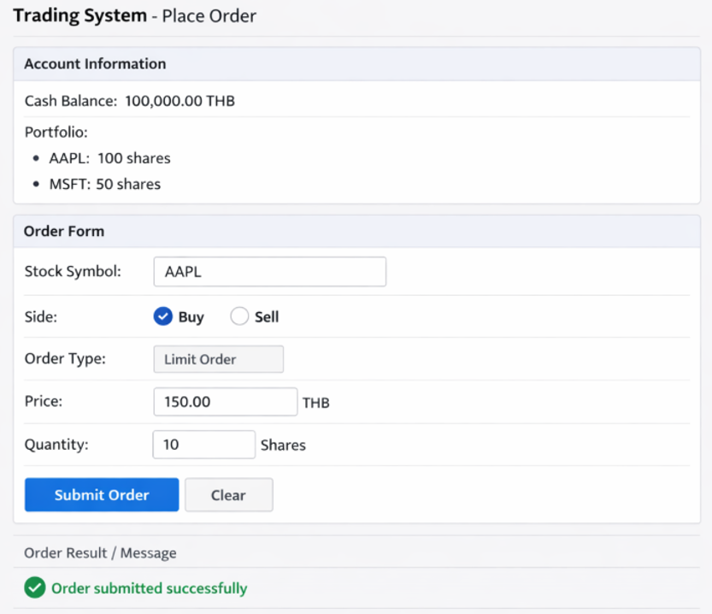

Html
<!-- ===== Account Information ===== -->
<section id="account-info">
<div id="cash-balance"> Cash Balance:
<span id="cash-amount">100000</span>
<span class="currency">THB</span>
</div>
<div id="portfolio">
<li data-symbol="AAPL"> AAPL:
<span class="shares" data-testid="shares-AAPL">100</span> shares
</li>
</div>
</section>

<!-- ===== Order Form ===== -->
<section id="place-order">
<form id="order-form">
<!-- Stock Symbol -->
<div class="form-row">
<label for="stock-symbol">Stock Symbol</label>
<input type="text" id="stock-symbol" name="symbol" data-testid="input-symbol"/>
</div>
<!-- Side -->
<div class="form-row">
<input type="radio" id="side-buy" name="side" value="BUY” checked data-testid="radio-buy" />
<label for="side-buy">Buy</label>
<input type="radio" id="side-sell" name="side" value="SELL" data-testid="radio-sell" />
<label for="side-sell">Sell</label>
</div>
<!-- Price -->
<div class="form-row">
<label for="price">Price</label>
<input type="number" id="price" name="price" step="0.01" data-testid="input-price" />
</div>
<!-- Quantity -->
<div class="form-row">
<label for="quantity">Quantity</label>
<input type="number" id="quantity" name="quantity" data-testid="input-quantity" />
</div>
<!-- Buttons -->
<div class="form-row">
<button type="submit" id="submit-order" data-testid="btn-submit"> Submit Order </button>
<button type="reset" id="clear-order" data-testid="btn-clear"> Clear </button>
</div>
</form>
</section>

<!-- ===== Result / Message ===== -->
<section id="order-result">
<div id="success-message" class="message success" data-testid="msg-success" style="display:none;"> Order submitted successfully </div>
<div id="error-message" class="message error" data-testid="msg-error" style="display:none;">Insufficient balance</div>
</section>

Your code

